

“PRIVATE UNIVERSITIES DEGREE PROGRAM ANALYSIS”



# INTRODUCTION:

The purpose of this graph analysis is to analyze Private Universities Degree program from undergraduate to PhD, and to map it in the form of Graph having NODES and EDGES. Here, we have considered our universities as Vertices/Nodes and the Degree Programs as Edges.

|  |  |  |
| --- | --- | --- |
| UNIIVERSITIES | PROGRAMS |  |
| Vertices | **Edges** | **AVERAGE DEGREE** |
| 61 | **1646** | **3.1086** |

# DATA COLLECTION:

Data is collected from Universities Website.

# GRAPH:

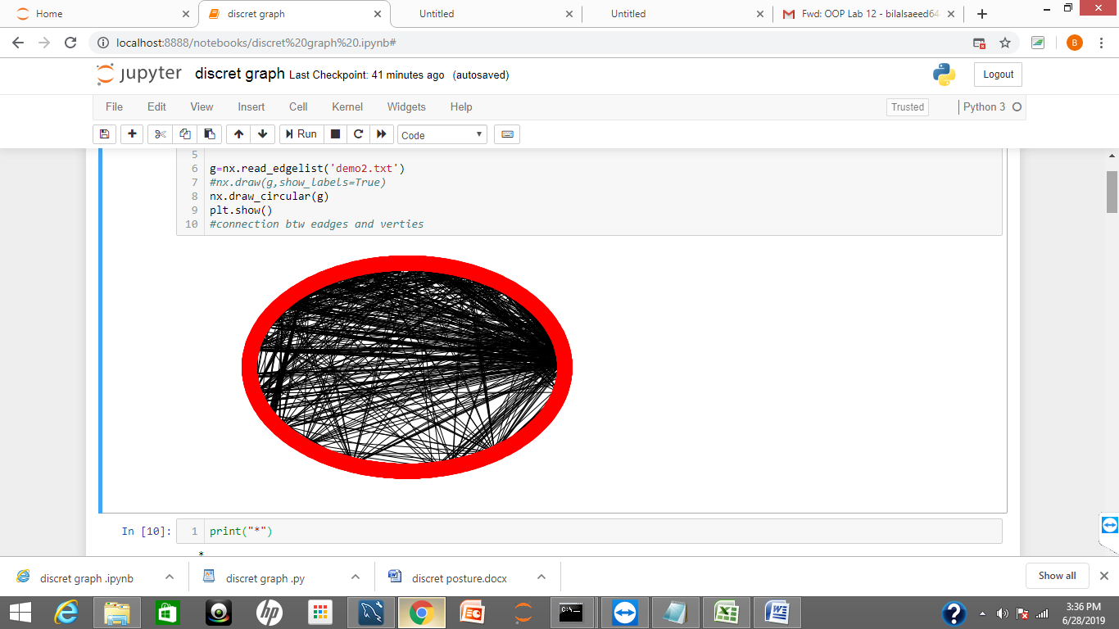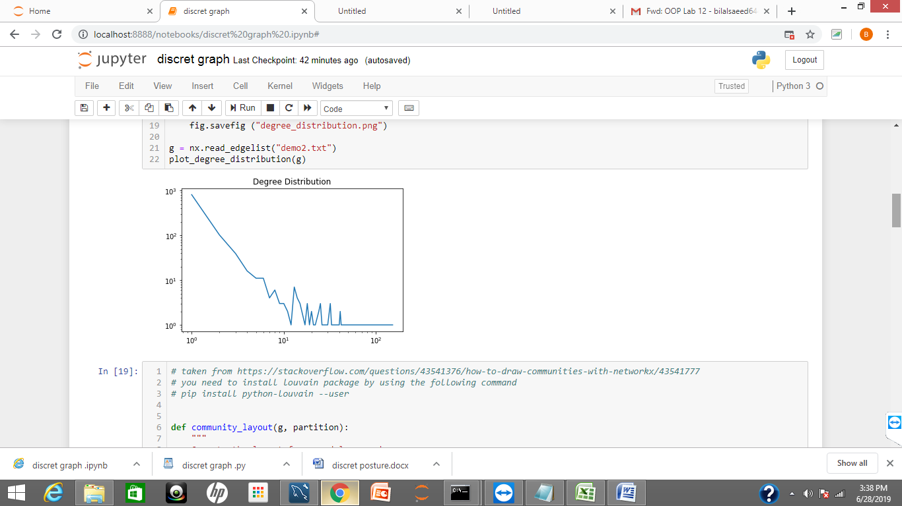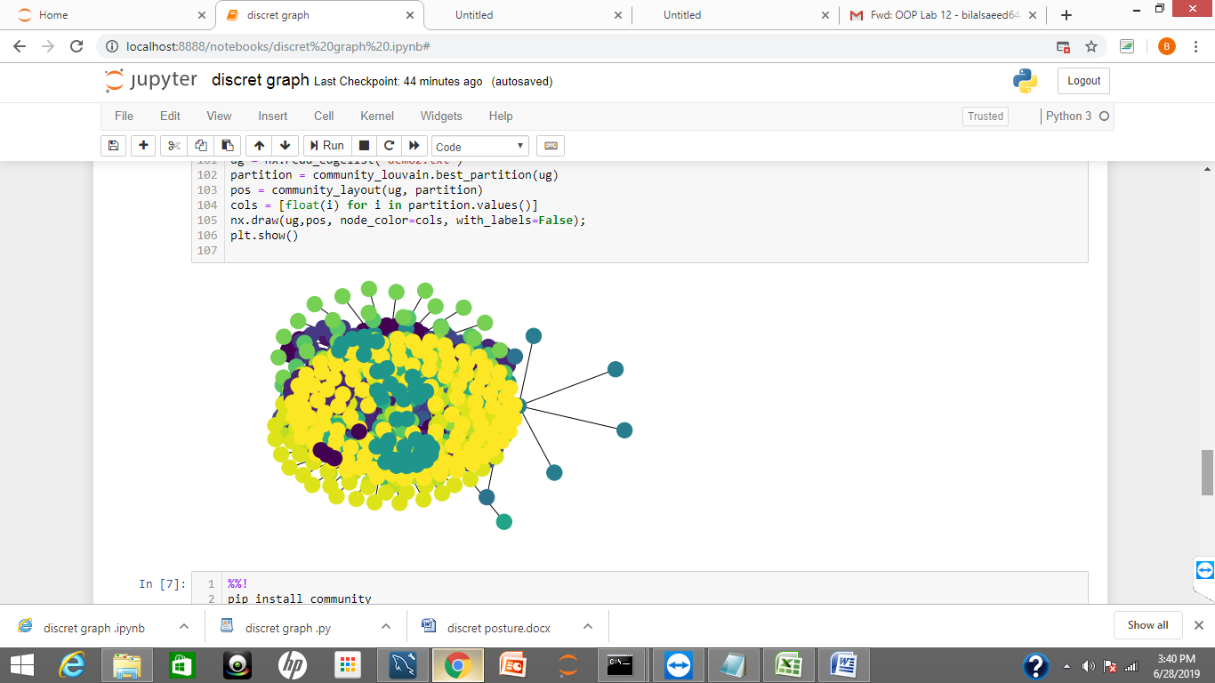

IN THIS GRAPH DOTS REPRESENT UNIVERSITES AND CONNECTION IS MADE BY SIMILAR PROGRAMS OFFERED BY THE UNIVERSITY

THIS GRAPH SHOWS DEGREE DISTRIBUTION .

THIS GRAPH SHOWS RELATION BETWEEN NODES AND EDGES.